Chapter 1: Introduction

  - Aim of the Project

TrackMyLogs is a system monitoring tool designed to facilitate the collection, transfer, and visualization of logs from a Windows application to a web-based platform. The application aims to provide users with a user-friendly interface for managing logs, enabling them to gain insights and make informed decisions based on log data.

  - Project Scope

- The collected logs will be compiled into a PDF and delivered to the registered email ID upon completion.
- Django is used for creating software download systems and managing authentication keys.
- Integration of secure data transfer protocols (HTTPS).
- User authentication and role-based access control (RBAC).
- Analytical tools for identifying trends and generating reports.

  - Project Objective

- To develop a Windows application that allows users to generate logs easily.
- To implement a secure and efficient method for transferring logs to a web server.
- The logs generated will be converted into a PDF and sent to the registered email ID at the end.
- To provide users with tools for log analysis, including reporting and visualization features.

  - Project Modules

- Log Generation Module.
- Log Transfer Module.
- Log Display Module
- User Authentication Module.
- Log Analysis Module.
- Key Management Module.

  - Project basic requirements

    - Hardware Requirements
Client Machine: Windows 10 or later, minimum 4 GB RAM, minimum 500 MB free disk space.
    - Software Requirements
- Development Environment: Python 3.x, Django framework, SQLite database, redis,Windows application development tools (e.g., PyQt or Tkinter).
- Web Browser: Latest version of Chrome, Firefox, or Edge for accessing the web application

Chapter 2: Analysis, Design Methodology and Implementation Strategy

2.1 Comparison of Existing Applications with your Project / Literature review.

Comparison of Existing Applications with your Project:

Features | TrackMyLogs | Splunk | Loggly
Log Generation | Yes | Yes | Yes
Log Display | Yes | Yes | Yes
User Authentication | Yes | Yes | Yes
User Analysis | Yes | Yes | Yes
User Activity Tracking | Yes | No | No
Multi User Support | Yes | Yes | Yes
Automated Log Cleanup | Yes | No | No
Mobile Support | No | Yes | Yes

Table 2.1 Comparison Table of Existing Application

Literature Review:

2.1.1 Title: "Log Management: Challenges and Solutions"
Abstract:
This paper discusses the various challenges faced in log management, including data volume, format inconsistencies, and security concerns. It presents solutions such as standardized log formats and automated log analysis tools to enhance the efficiency of log management systems.
Summary:
The authors highlight the importance of adopting standardized log formats to improve data consistency and facilitate easier analysis. They also emphasize the need for automated tools that can process large volumes of log data, reducing the manual effort required for log management. The paper concludes with recommendations for organizations to implement best practices in log management[1].

2.1.2 Title: "Secure Log Transfer Protocols: A Comparative Study"
Abstract:
This study evaluates various secure log transfer protocols, focusing on their effectiveness in protecting sensitive log data during transmission. The authors compare HTTPS, SFTP, and other protocols, providing insights into their strengths and weaknesses.
Summary:
The findings indicate that HTTPS is the most widely adopted protocol for secure log transfer due to its ease of implementation and strong encryption capabilities. The study also discusses the importance of user-configurable endpoints for flexibility in log management systems. The authors recommend adopting HTTPS as a standard for secure log transmission[2].
2.1.3 Title: "User -Centric Design in Log Management Systems"
Abstract:
This research explores the significance of user-centric design in log management systems. It examines how user interface (UI) and user experience (UX) impact the effectiveness of log analysis and management.
Summary:
The authors argue that an intuitive UI and UX are critical for enabling users to efficiently navigate and analyze log data. They provide case studies demonstrating how well-designed interfaces can lead to improved user satisfaction and faster decision-making. The paper advocates for incorporating user feedback into the design process to create more effective log management tools[3].

2.1.4 Title: "Analyzing Log Data: Techniques and Tools"
Abstract:
This paper reviews various techniques and tools for analyzing log data, including statistical methods, machine learning algorithms, and visualization tools. It discusses the advantages and limitations of each approach.
Summary:
The authors highlight the growing importance of advanced analytical techniques in log management, particularly in identifying trends and anomalies. They provide a comparative analysis of popular tools used for log analysis, emphasizing the need for integration with existing log management systems. The paper concludes with recommendations for selecting appropriate tools based on organizational needs[4].

2.1.5 Title: "Role-Based Access Control in Log Management"
Abstract:
This study investigates the implementation of role-based access control (RBAC) in log management systems. It discusses the benefits of RBAC in enhancing security and managing user permissions effectively.
Summary:
The authors demonstrate that RBAC can significantly improve the security of log management systems by ensuring that only authorized users have access to sensitive log data. They provide guidelines for implementing RBAC, including defining user roles and permissions. The paper emphasizes the importance of balancing security with usability to maintain an effective log management process[5].
2.2 Project Feasibility Study

2.2.1 Financial Feasibility
- Operational Costs: Ongoing expenses will include server hosting fees, maintenance costs, and potential marketing expenses to promote the application.
- Revenue Projections: The application may generate revenue through subscription models, licensing fees, and consulting services related to log management.
- Return on Investment (ROI): A cost-benefit analysis will be conducted to compare total costs against expected financial benefits, estimating the time required to break even.
- Market Demand: An analysis of market demand for log management solutions will help justify the financial investment and guide pricing strategies.

2.2.2 Technical Feasibility
- Technology Stack: The application will utilize Python and Django for backend development, with MySQLite for database management.
- System Architecture: A client-server model will be implemented, allowing to generate logs and a web application for analysis.
- Integration Capabilities: The application will support secure data transfer using HTTPS and may integrate with existing logging frameworks.
- Resource Availability: The development team possesses the necessary skills in the chosen technologies, ensuring effective project execution.
- Development Tools: Availability of required development tools and environments will be assessed to facilitate the development process.
2.2.3 Operational Feasibility
- User Adoption: The application is designed to be user-friendly, which should facilitate adoption among users with varying technical skills.
- Training Requirements: Minimal training will be required for users, as the application will include intuitive interfaces and help documentation.
- Compliance and Standards: The application will adhere to relevant data protection regulations and industry best practices for software development.
- Risk Assessment: Potential risks associated with project execution will be identified, along with strategies to mitigate these risks

2.3 Project Timeline chart
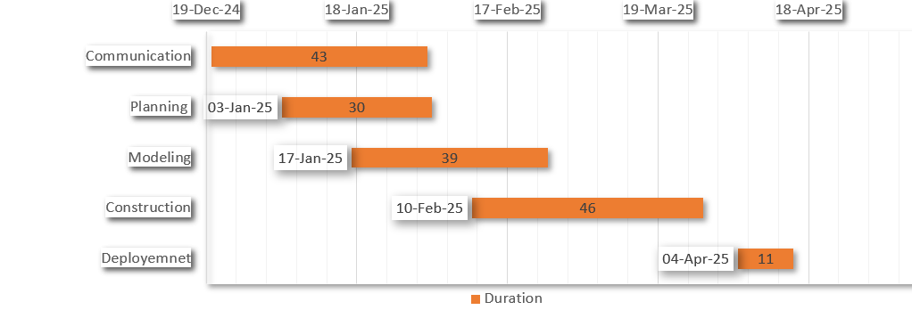
Figure 2.1 Project Timeline chart

  - Detailed Modules Description

- Log Generation Module:

This module operates on the client-side (Windows system) and is responsible for capturing real-time system and application events. It utilizes the list of python modules to access Windows Event Logs and generate structured logs, including application usage, system events, and optionally network activity. The logs are formatted in a consistent structure for smooth parsing and further processing. This module also includes filters to select relevant logs and avoid excessive data generation.

- Log Transfer Module:

Once the logs are generated, this module handles their secure and efficient transmission to the Django-based web server. HTTPS protocol is used to encrypt and protect data during transit. A lightweight REST API is designed to receive log files from client machines. The module also ensures that logs are temporarily stored in Redis until they are processed or saved permanently, preventing data loss during network interruptions.
- Log Display Module:
After the logs are received by the server, this module manages their visualization in the web application. It fetches and processes the logs from the backend, converting them into user-readable formats such as tables and charts using tools like Matplotlib and Chart.js. It also supports search, filtering, and pagination to enhance the user experience when browsing large volumes of log data. Users can request a PDF compilation of the logs, which is automatically generated and emailed to them.
- User Authentication Module:

This module secures the application by providing functionalities for user registration, login, and session management. Built using Django’s authentication system, it supports password hashing, user verification, and token-based session control. Role-Based Access Control (RBAC) is implemented to restrict access to certain features (e.g., only staff users can generate tokens or view analytics). This ensures data privacy and personalized experiences.
- Log Analysis Module:

To derive actionable insights from raw log data, this module performs automated analysis such as frequency tracking, error rate detection, and anomaly identification. It supports graphical representations for system behavior trends, active time graphs, and suspicious activity reports. In future iterations, this module may incorporate ML-based anomaly detection for advanced analytics.

- Key Management Module:

To ensure that each user securely interacts with their own log environment, this module manages authentication keys. Upon request (post-login), a unique key is generated for each user. The key is stored in the backend (SQLite) and associated with that specific user account. This module ensures that only one key per user is generated to avoid misuse.

2.5 Project SRS
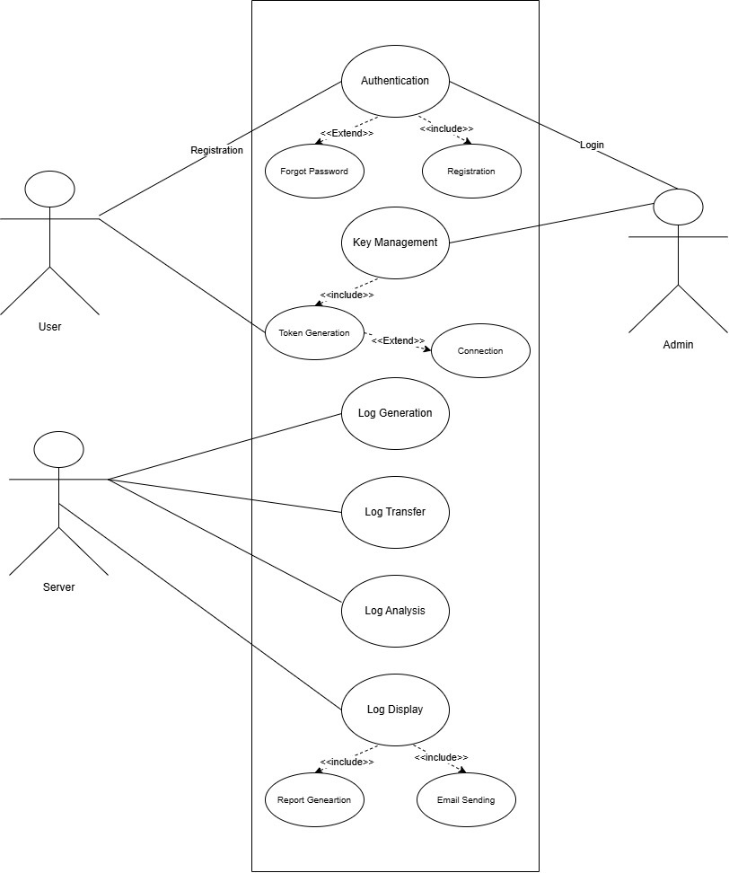
2.5.1 Use Case Diagrams

Figure 2.2 Use Case Diagram

2.5.2 Data Flow Diagrams
Level 0:
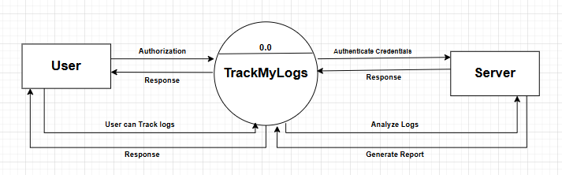
Figure 2.3 DFD Level 0
Level 1:
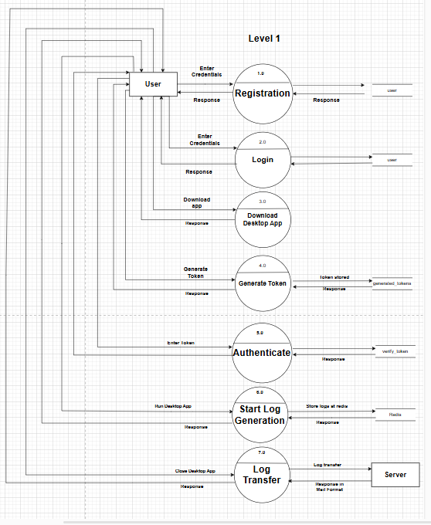
Figure 2.4 DFD Level 1

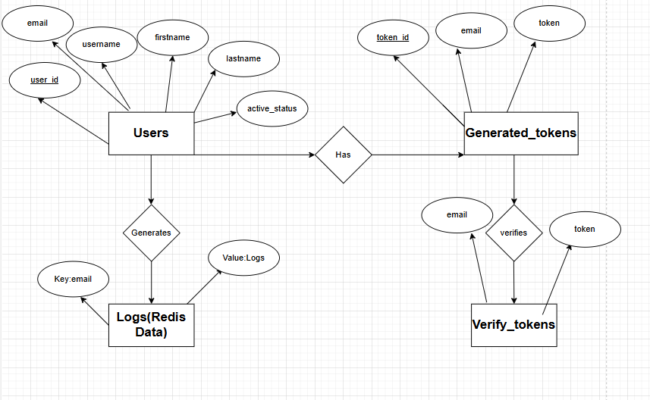
2.5.3 Entity Relationship Diagrams
Figure 2.5 ER Diagram

2.5.4 Event Trace Diagram
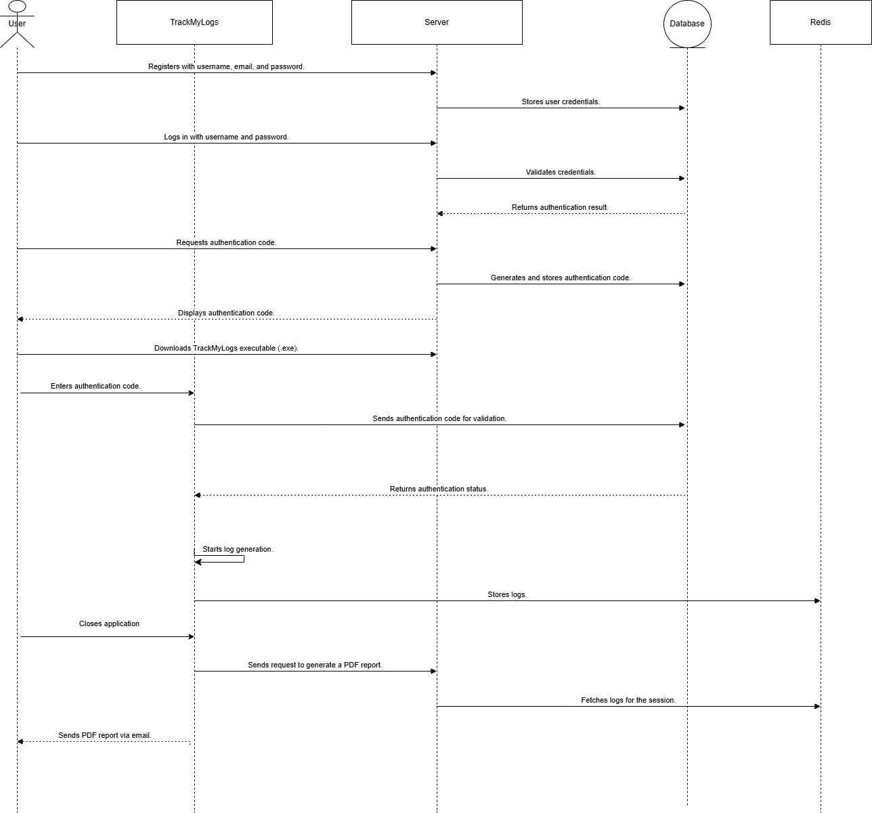

Figure 2.6 Event Trace Diagram

2.5.5 State diagram for Web Application
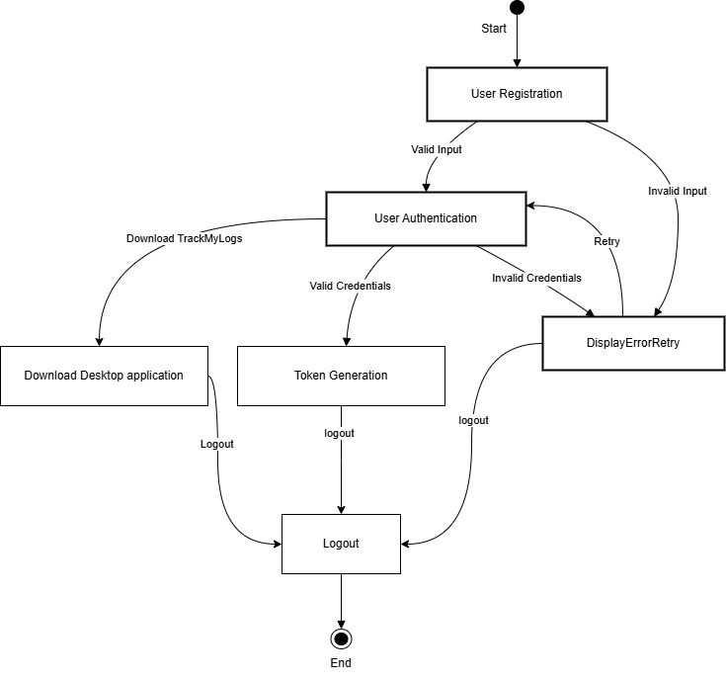
Figure 2.7 State Diagram for Web Application

2.5.6 State diagram for Desktop Application

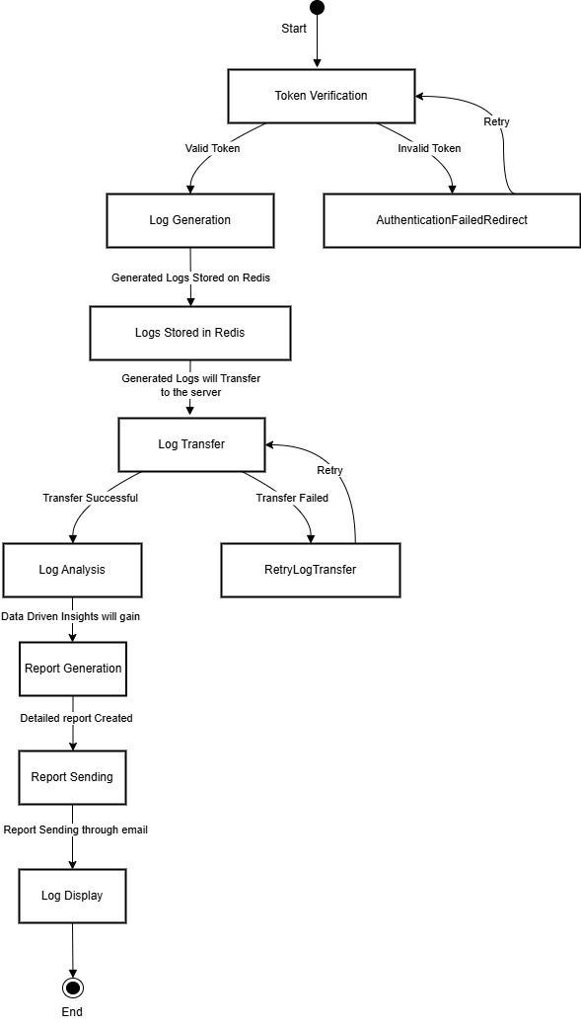
Figure 2.8 State Diagram for Desktop Application

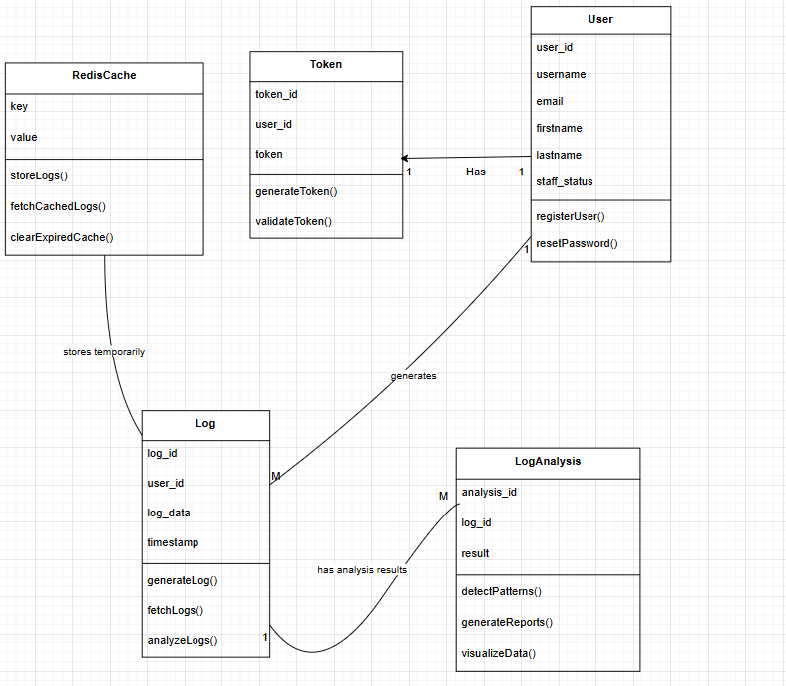
2.5.7 Class diagram

Figure 2.9 Class Diagram

2.6 Database design and Normalization
SQLLite Tables:
2.6.1 Users
Column Name | Data Type | Description
user_id | Int | Unique identifier for each user
Username | Varchar | Username of the user
Email | Varchar | Email address of the user
Firstname | Varchar | First name of the user (nullable)
Lastname | Varchar | Last name of the user (nullable)
Staff_status | Varchar | Indicates if the user is a staff member

Table 2.2 Users Table Schema

2.6.2 Generated_Tokens
Column Name | Data Type | Description
Id | Int | Unique identifier for each token
Username | Varchar | Username of the user
Email | Varchar | Email address of the user
Token | Varchar | The Token of the user

Table 2.3 Generated_token Table Schema

2.6.3 Redis Data

Key | Value | Description
Emails | Logs | Stores log data for specific events or errors.

Table 2.4 Redis Key-Value data structure

2.7 Database Relation Diagram

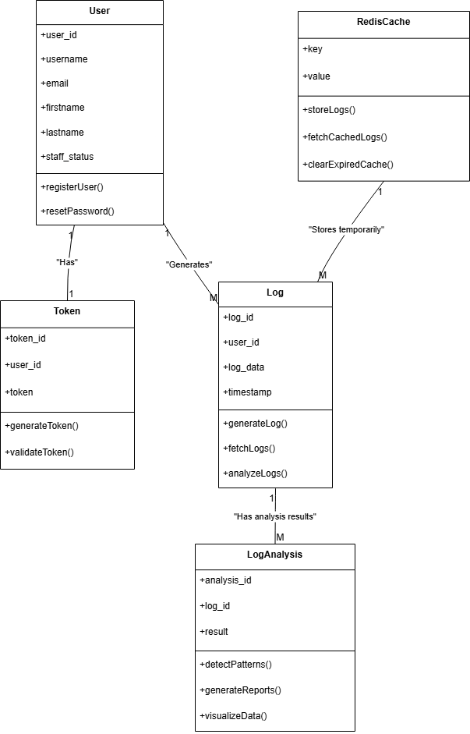
Figure 2.10 Database Relation Diagram
2.8 Template Design

2.8.1 Login Signup Page:
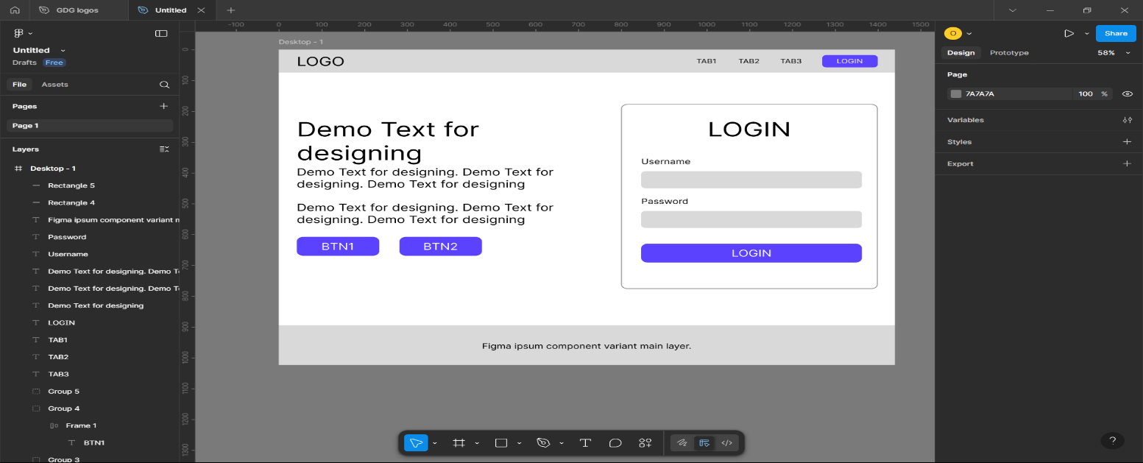
Figure 2.11 Template Design Preview 1

- Initial Design Template for the login/Signup page to get the user reviews.
2.8.1 Home Page:
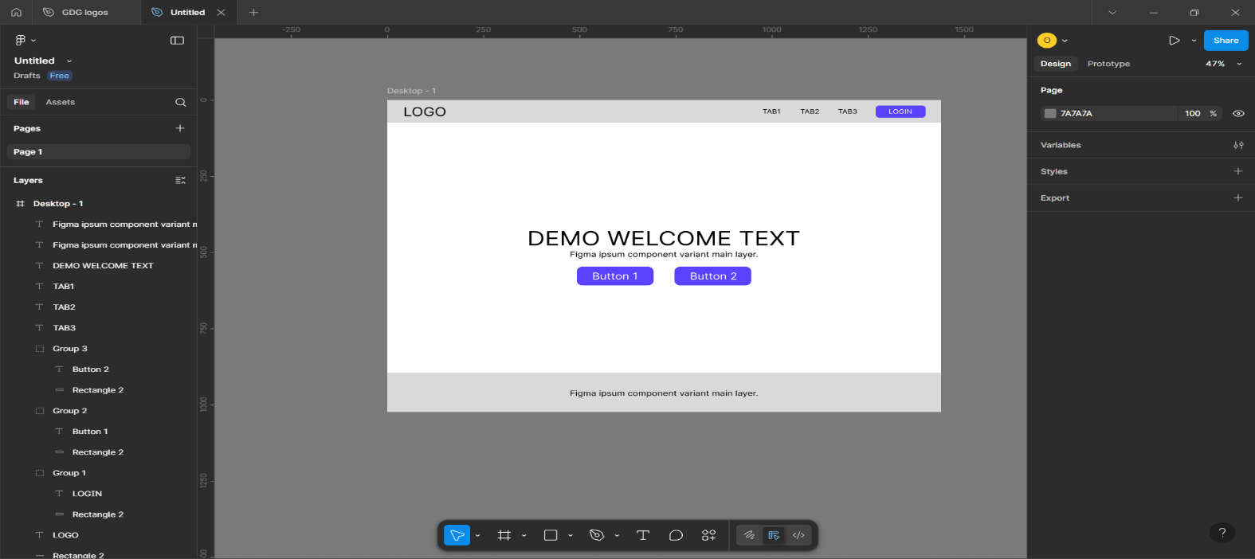
Figure 2.12 Template Design Preview 2

- Initial Design Template for the Home Page to get the user reviews.
Chapter 3: Implementation and Testing

3.1 Software and Tools
The following software and tools were used during the development, testing, and documentation of the TrackMyLogs project:
- Visual Studio Code
Served as the primary code editor for developing the application using Python (Django framework) along with HTML, CSS, and JavaScript for the frontend. Its integrated terminal and extensions greatly enhanced productivity.
- Web Browsers (Google Chrome)
Used extensively for testing the Django web application, verifying UI functionality, debugging with developer tools, and accessing documentation and APIs.
- Draw.io
Utilized to design and generate key system diagrams such as the Entity-Relationship Diagram, Class Diagram, and Database Relation Diagram, which visually represent the backend structure and logic.
- Microsoft Word
Used to prepare and format the final project documentation, including the report, system design documentation, and technical descriptions.
- SQLite3 (with Django ORM)
Acted as the backend relational database for storing user data, logs, analysis results, and authentication tokens. Integrated seamlessly with Django’s Object Relational Mapper (ORM) for efficient database operations.

3.2 User Interface and Snapshot
3.2.1 Desktop App

Figure 3.1 Desktop App
- Upon launching the desktop application, the user is prompted to authenticate using the token provided on the web application. Once authenticated, the application begins monitoring and collecting logs in real-time from the user's Windows system. These logs include application usage, system events, and optionally, network activity. The application runs silently in the background, ensuring minimal disruption to the user's workflow while maintaining active log generation.
3.2.2 Login Page

Figure 3.2 Login Page
- The web application opens with a Login Page where users enter their registered email and password to access their dashboard. For new users, a registration link is provided. All login data is validated through Django’s secure authentication system, and upon success, the user is redirected to their personalized profile page.
3.2.3 Profile Page

Figure 3.3 Profile Page
- On the Profile Page, users can view their account information, including email, username, and whether they hold staff privileges. A core function on this page is the ability to generate or view their Authorization Token, which is required to authenticate the desktop application. If the token has already been generated, it is displayed and can be copied to the clipboard.
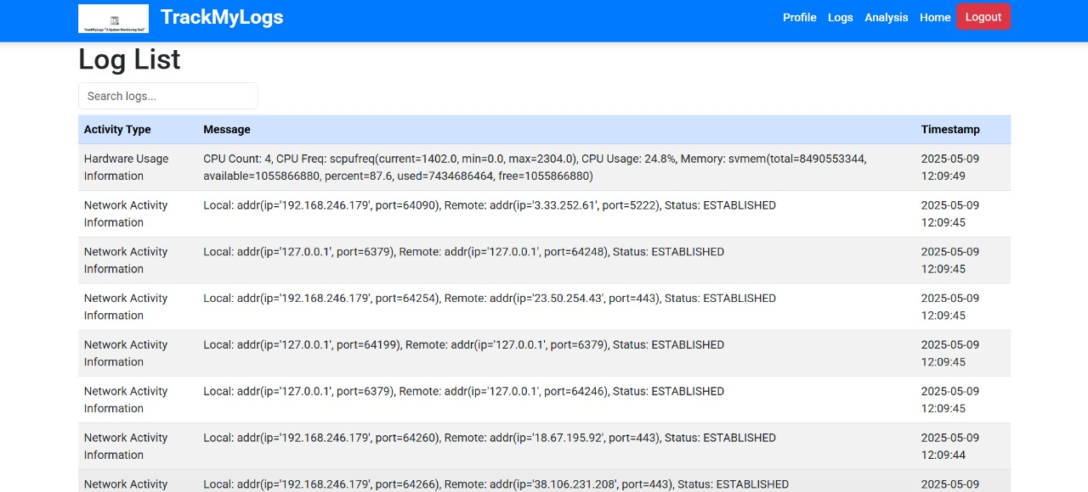
3.2.4 Logs Page

Figure 3.4 Logs Page
- After authentication, users can navigate to the Logs Page, where the logs collected by the desktop application are displayed in an organized tabular format. Users have access to powerful filtering options. Users can also perform searches and sort the data dynamically. This ensures efficient navigation even when dealing with large datasets.

3.2.5 Analysis Page
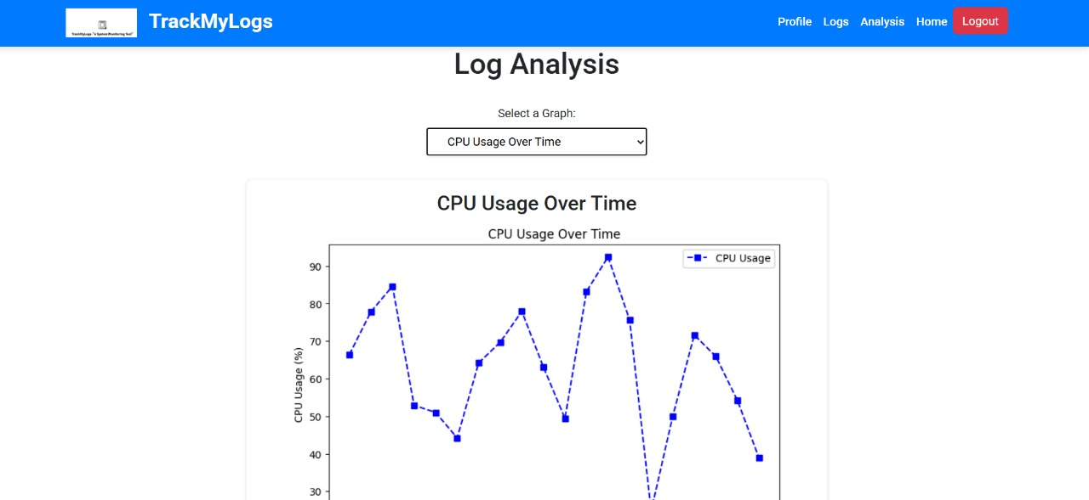

Figure 3.5 Analysis Page
- The Analysis Page transforms raw log data into insightful visualizations. Users are presented with a set of interactive charts and graphs. These visualizations include:
- Frequency of system/application events
- Error occurrence trends
- User activity graphs
- Anomalies or spikes in usage
- From this page, users can also export the analyzed logs into a PDF report, which is automatically emailed to their registered account. This report serves as a portable, shareable version of their log analysis.

3.3 Testing using Use Cases
3.3.1 Registration (Sign Up):
Test Case | Test Data | Test Result | Test Report
Blank email, password, confirm password | Email: -  Password:-  Confirm Password: - | Invalid | Please enter the details
Existing email, password, confirm password | Email: admin@gmail.com  Password: 98766  Confirm Password: 98766 | Invalid | Email id already registered
Valid email, password and confirm password | Email: abc@gmail.com  Password: user123  Confirm Password:  user123 | Valid | Welcome message
Table 3.1 Testing Report Registration (Sign Up)
3.3.2 Login
@gmail.com

Table 3.2 Testing Report Login

3.3.3 Forgot Password
Table 3.3 Testing Report Forgot Password

3.3.4 Download Desktop App

Table 3.4 Download Desktop App

3.3.5 Authorization Token
Table 3.5 Testing Report Authorization Token
3.3.6 Desktop App Authentication
Table 3.6 Testing Report Desktop App Authentication

3.3.7 Types of Log generation
Table 3.7 Testing Report Types of Logs Generation

Chapter 4: Conclusion and Future work
4.1 Conclusion
The TrackMyLogs project successfully implements a web-based log monitoring and visualization system that collects system logs from client machines, temporarily stores them using Redis, and then processes them using a Django-based backend. The system performs automated log analysis to detect meaningful patterns, generate summarized reports, and visualize data in a user-friendly format. Through this platform, users can efficiently track and diagnose system behavior, enhancing both system performance and security monitoring. The project's modular architecture and use of open-source technologies ensured ease of development, maintainability, and scalability.
4.2 Future work
To further enhance the TrackMyLogs system, the following improvements and features can be considered in the future:
- Alert System: Introduce a threshold-based or anomaly detection alert mechanism to notify users of unusual activity via email or dashboard notifications.
- Cloud Storage Integration: Enable storing logs in cloud platforms like AWS S3 or Azure Blob for better scalability and reliability.
- Advanced Analytics with ML: Integrate machine learning algorithms to classify logs, detect anomalies, or predict failures.
- Dockerization and Deployment: Package the application using Docker and deploy it on cloud infrastructure for broader availability and testing.
- Dark Mode & Theme Customization: Enhance user experience by allowing UI customization.

Web References
Websites Used as References
- https://www.djangoproject.com/ – Official site for Django framework
- https://www.sqlite.org/ – SQLite documentation and features
- https://redis.io/docs/ – Official Redis documentation
- https://matplotlib.org/ – Data visualization in Python
- https://docs.python.org/3/ – Python official documentation
- https://getbootstrap.com/ – UI framework documentation

Literature References
Research Papers and Other Materials
[1] A. Sharma and N. Gupta, "Log Management: Challenges and Solutions," International Journal of Information Technology and Computer Science, vol. 12, no. 4, pp. 45–52, 2022.
[2] R. Verma and S. Thakur, "Secure Log Transfer Protocols: A Comparative Study," Journal of Cybersecurity and Data Protection, vol. 9, no. 1, pp. 12–19, 2021.
[3] M. Roy and P. Nair, "User-Centric Design in Log Management Systems," Human-Centric Computing and Information Sciences, vol. 7, no. 3, pp. 55–68, 2023.
[4] T. K. Sen and D. K. Patel, "Analyzing Log Data: Techniques and Tools," IEEE Access, vol. 11, pp. 7894–7907, 2023.
[5] J. Thomas and R. Iyer, "Role-Based Access Control in Log Management," ACM Transactions on Information and System Security (TISSEC), vol. 19, no. 2, pp. 1–18, 2020.

